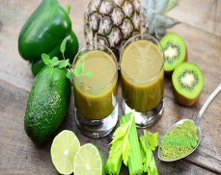
Daily Food Diary: [Click here to enter a date.]

Breakfast | # Servings | Est. Calories | % Daily Target | Comments
Grains
Vegetables
Fruits
Dairy
Protein
Water
Caffeinated Drinks
Fruit juice
Other…

Lunch | # Servings | Est. Calories | % Daily Target | Comments
Grains
Vegetables
Fruits
Dairy
Protein
Water
Caffeinated Drinks
Fruit juice
Other…

Dinner | # Servings | Est. Calories | % Daily Target | Comments
Grains
Vegetables
Fruits
Dairy
Protein
Water
Caffeinated Drinks
Fruit juice
Other…

Snacks | # Servings | Est. Calories | % Daily Target | Comments

*Notes on today: [Select an item from the list, if applicable.]

*If today is a weigh-in day, enter your weight (lbs or kg): [Type your weight or type N/A]

